**Dataset for Play Tennis**

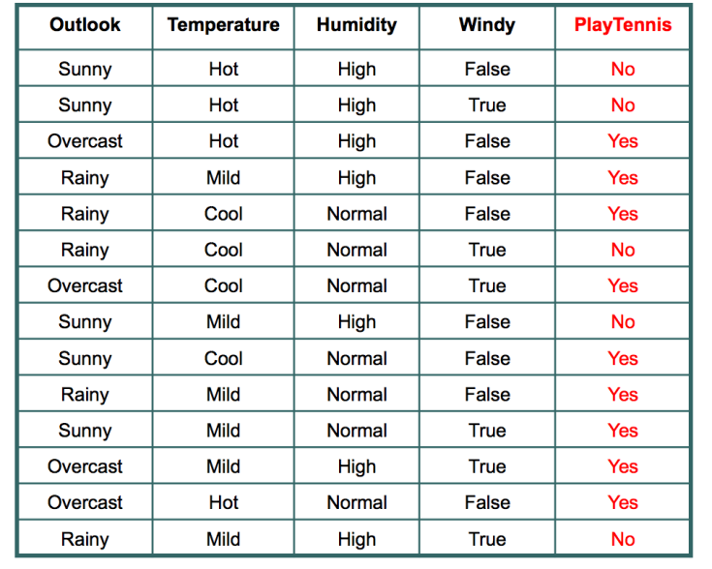

**Entropy**

Entropy is a measure of randomness. In other words, its a measure of unpredictability. We will take a moment here to give entropy in case of binary event(like the coin toss, where output can be either of the two events, head or tail) a mathematical face:

Entropy = -(probability(a) * log2(probability(a))) – (probability(b) * log2(probability(b)))

where **probability(a)** is probability of getting head and **probability(b)** is probability of getting tail.

Of course this formulae can be generalised for n discreet outcome as follow:

Entropy = -p(1)*log2(p(1)) -p(2)*log2(p(2))-p(3)*log2(p(3))………………………..p(n)*log(2p(n))

**Entropy is an important concept. You can find more descriptive explanation**[**here**](https://nullpointerexception1.wordpress.com/2017/12/13/entropy-in-machine-learning/)**.**

**Information Gain**

In the decision tree shown here:

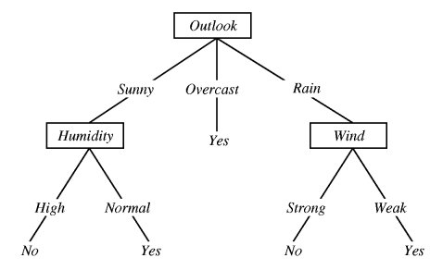

We decided to break the first decision on the basis of outlook. We could have our first decision based on humidity or wind but we chose outlook. Why?

Because making our decision on the basis of outlook reduced our randomness in the outcome(which is whether to play or not), more than what it would have been reduced in case of humidity or wind.

Let’s understand with the example here. Please refer to the play tennis dataset that is pasted above.

We have data for 14 days. We have only two outcomes :

Either we played tennis or we didn’t play.

1. In the given 14 days, we played tennis on 9 occasions and we did not play on 5 occasions.

Probability of playing tennis:

Number of favourable events : 9

Number of total events : 14

Probability =  (Number of favourable events) / (Number of total events)

= 9/14

= 0.642

Now, we will see probability of not playing tennis.

Probability of not playing tennis:

Number of favourable events : 5

Number of total events : 14

Probability =  (Number of favourable events) / (Number of total events)

=5/14

=0.357

And now entropy of outcome,

Entropy at source= -(probability(a) * log2(probability(a))) – (probability(b) * log2(probability(b)))

= -(Probability of playing tennis) * log2(Probability of playing tennis) – (Probability of not playing tennis) * log2(Probability of not playing tennis)

= -0.652 * log2(0.652) – 0.357*log2(0.357)

=0.940

**So, entropy of whole system before we make our firest question is 0.940**

Now, we have four features to make decision and they are:

1. Outlook
2. Temperature
3. Windy
4. Humidity

Let’s see what happens to entropy when we make our first decision on the basis of Outlook.

**Outlook**

If we make a decison tree divison at this level 0 based on outlook, we have three branches possible; either it will be Sunny or Overcast or it will be Raining.

1. Sunny : In the given data, 5 days were sunny. Among those 5 days, tennis was played on 2 days and tenis was not played on 3 days. What is the entropy here?

Probablity of playing tennis = 2/5  = 0.4

Probablity of not playing tennis = 3/5 = 0.6

Entropy when sunny = -0.4 * log2(0.4) – 0.6 * log2(0.6)

= 0.97

2. Overcast: In the given data, 4 days were overcast and tennis was played on all the four days. Let

Probablity of playing tennis = 4/4  = 1

Probablity of not playing tennis = 0/4 = 0

Entropy when overcast = 0.0

3. Rain: In the given data, 5 days were rainy. Among those 5 days, tennis was played on 3 days and tenis was not played on 2 days. What is the entropy here?

Probablity of not playing tennis = 2/5  = 0.4

Probablity of playing tennis = 3/5 = 0.6

Entropy when rainy = -0.4 * log2(0.4) – 0.6 * log2(0.6)

= 0.97

Entropy among the three branches:

Entropy among three branches = ((number of sunny days)/(total days) * (entropy when sunny)) + ((number of overcast days)/(total days) * (entropy when overcast)) + ((number of rainy days)/(total days) * (entropy when rainy))

= ((5/14) * 0.97) + ((4/14) * 0) + ((5/14) * 0.97)

= 0.69

What is the reduction is randomness due to choosing outlook as a decision maker?

Reduction in randomness = entropy source – entropy of branches

= 0.940 – 0.69

= 0.246

This reduction in randomness is called **Information Gain**. Similar calculation can be done for other features.

**Temperature**

Information Gain = 0.029

**Windy**

Information Gain = 0.048

**Humidity**

Information Gain = 0.152

We can see that decrease in randomness, or information gain is most for Outlook. So, we choose first decision maker as **Outlook**.